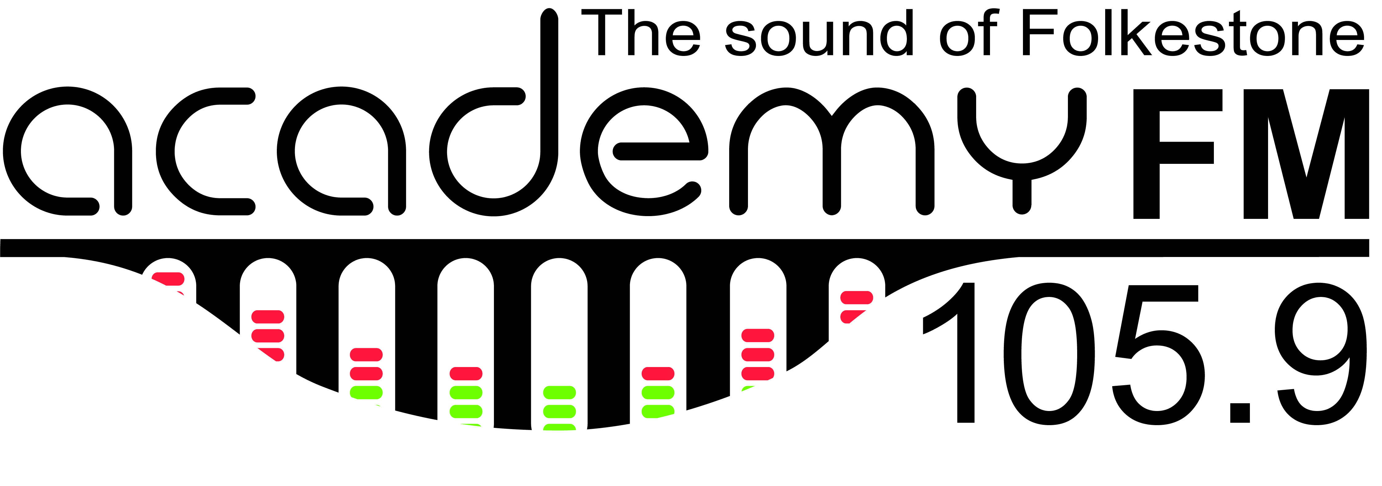
Join the Friends of Academy FM

£25 Individual Friend

£100 Join as a Business Friend

£120 Additional Package - Value
£35 p/m Extend Value package small web ad and Facebook posts

£250 Additional Package – Extended Presence
£75 p/m Extend large web ad and timed thank-you message

£300 Additional Package – Impact
£90 p/m Extend web banner ad and timed thank-you message

£150 Pre-roll audio advert on our web stream
£neg. We broadcast from your event, or DJ at your work party (range £225-£300)

Name:
Business name (if applicable)
Address:
Phone:
Email:
Total donation:
Gift Aid:  (Individual Friends) | Are you a UK Taxpayer? By signing below your donation can be increased by nearly a third, and it won’t cost you. I want Academy FM Folkestone to treat all my donations from this date until further notice as Gift Aid donations  Signature:_______________________ Date: __________________  You must pay an amount of income tax and/or capital gains equal to the tax we reclaim on your donations. Please notify us if your tax circumstances change and this is no longer the case.
Payment by cheque | Made payable to: Academy FM Folkestone  Post cheque & this form to: Academy FM, The Folkestone Academy,  Folkestone, Kent CT195FP
Paypal, Standing Order or Bank Transfer | Contact: friends@academyfmfolkestone.com for details

